https://www.sida.se/globalassets/sida/eng/how-we-work/humanitarian-aid/hca-2019/hca-yemen-2019.pdf
https://news.un.org/en/story/2019/02/1032811

Man-made Disasters: War, displacement, famine

- Look up the top ten ongoing humanitarian crises around the world.
Yemen
Crisis Analysis Yemen 2019
Our humanitarian support in Yemen
- Select one and write your discussion post on that crisis.
- For example:
One of the major ongoing international crises is the humanitarian crisis in Yemen that has been fueled by war, political, economic, and another social upheaval in the region.

The focus of the assignment is to bring attention to an ongoing crisis that appears to get little attention in the west but is considered one of the worst humanitarian crises in our time. We are concerned about humanitarian issues as it relates to global health-related issues. Read up on current news reports on what is happening in the crisis you selected. For example, if you selected the Yemen situation you would:

- Discuss in what ways this complex humanitarian crisis is both a local and an international event and your views on how various nations have responded.
https://www.atlanticcouncil.org/blogs/menasource/the-problem-with-humanitarian-assistance-in-yemen/
Two of the leading international parties in the conflict—Saudi Arabia and the United Arab Emirates—are among Yemen’s top humanitarian donors; together pledging roughly $1 billion, this year alone. Major allies of the Saudi-led coalition—the UK and the US—also made large donations this year of $237 million and $87 million respectively.

Perhaps most devastating is the naval blockade, resulting in major food shortages in Yemen

There is an innate conflict of interest in selling the weapons that perpetuate the suffering of Yemen’s civilian population while also sending humanitarian assistance and funding. And absent a political will to end the conflict, efforts by donor countries to support the people of Yemen, including humanitarian actions, are compromised.

https://reliefweb.int/report/yemen/donors-pledge-2-billion-scale-aid-delivery-yemen-enar
International donors today pledged more than US$2 billion to support the delivery of urgently needed humanitarian aid to millions of people in Yemen during a pledging event in Geneva, co-chaired by the United Nations, Sweden and Switzerland
humanitarian resources are very important, but they are not enough.
Above all, we need a serious political process to lead to a political solution.
On 27 March, the Kingdom of Saudi Arabia and the United Arab Emirates provided $930 million toward the YHRP which is reflected in today’s pledging result.
Humanitarian aid alone cannot be the response to the growing needs of the Yemeni people endangered by the armed conflict
A political solution must imperatively be found. Switzerland calls for a cessation of hostilities and invites all parties to join the negotiating table.
The humanitarian situation in Yemen is considered the worst in the world. Twenty-two million people – three-quarters of the population – require some form of humanitarian assistance

- Look for a publicly available photo that depicts this man-made disaster. Share the photo and give appropriate credit.

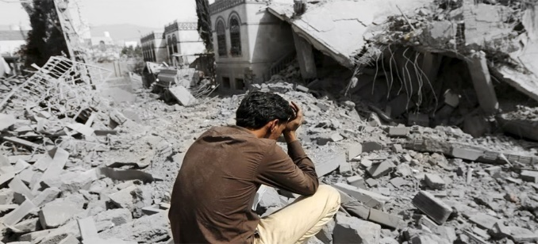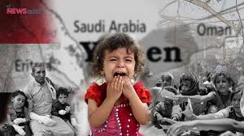

- Briefly discuss what you think are the most urgent needs of the residents and citizens of the nation
https://www.csmonitor.com/World/Middle-East/2015/0722/Can-Yemen-s-government-rebuild-the-country-and-its-own-legitimacy

Civil society leaders and activists have been quick to call on the government to facilitate aid and restore basic services.

“Displaced are returning to liberated areas to find a lack of electricity and water services, no health services and the spread of epidemic disease,” the committee said in a press statement. “The government needs to work hard and fast.”

Reconnecting Yemen to the world
Security will be key
Cash will pay for some success

- Do you think adequate attention is being paid to this crisis? Why or why not?
https://www.dw.com/en/war-in-yemen-the-world-isnt-paying-enough-attention/a-41750040

http://www.thenewhumanitarian.org/analysis/2016/02/11/why-does-no-one-care-about-yemen
1- Syria
Crisis Analysis Syria 2019
Our humanitarian support in Syria
Our development cooperation in Syria
2- Yemen
Crisis Analysis Yemen 2019
Our humanitarian support in Yemen
3- DR Congo
Crisis Analysis DR Congo 2019
Our humanitarian support in DR Congo
Our development cooperation in DR Congo
4- South Sudan
Crisis Analysis South Sudan 2019
Our humanitarian support in South Sudan
Our development cooperation in South Sudan
5- Afghanistan
Crisis Analysis Afghanistan 2019
Our work in Afghanistan
6- Somalia
Crisis Analysis Somalia 2019
Our work in Somalia
7- Palestine
Crisis Analysis Palestine 2019
Our work in Palestine
8- Sudan
Crisis Analysis Sudan 2019
Our work in Sudan
9- Myanmar (Burma)
Crisis Analysis Myanmar 2019 (including the Rohingya crisis in Bangladesh)
Our work in Myanmar
10- Central African Republic
Crisis Analysis CAR 2019
11- Iraq
Crisis Analysis Iraq 2019
Our work in Iraq
12- Ethiopia
Crisis Analysis Ethiopia 2019
Our work in Ethiopia
13- Lake Chad Basin
Crisis Analysis Lake Chad Basin 2019
14- Chad
Crisis Analysis Chad 2019
15- Niger
Crisis Analysis Niger 2019
16- Nigeria
Crisis Analysis Nigeria 2019
17- Cameroon
Crisis Analysis Cameroon 2019
18- Mali
Crisis Analysis Mali 2019
Our work in Mali
19- Venezuela
Crisis Analysis Venezuela and Colombia 2019

